Test Case ID
TC_001

Test Case Name
Search based on date filter

Test Scenario
User selected a valid date range and search for all logs types in all folders

Preconditions
N/A

Test Steps
· Launch the application and select a valid From Date and To Date
· Keep all other fields as default (All)
· Click the Search button.

Expected Result
- Verify that all displayed records fall within the selected date range.
- Verify that records beyond the date range are not displayed.

Actual Result

1) After selecting Date range
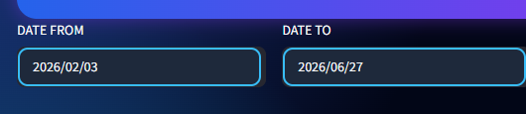

Records are displayed successfully based on the selected date range
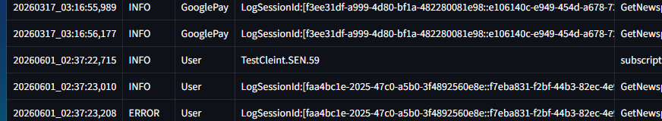
2) After selecting Date range

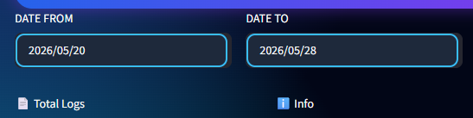
The records shows No matching logs found.



Test Case ID
TC_002

Test Case Name
Search based on date filter
Test Scenario
Users select an invalid date range and search for all logs types in all folders.

Preconditions
N/A

Test Steps
· Launch the application and select an invalid From Date and To Date
· Keep all other fields as default (All)
· Click the Search button.

Expected Result
1)Verify that an error message is displayed when the “Date From” value is greater than the “Date to” value.
Actual Result

1) After selecting "Date from” value which is greater than the “Date to” value.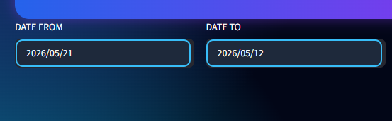

The record shows
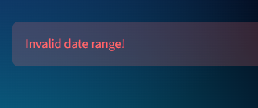
Test Case ID
TC_003

Test Case Name
Search based on Folder and Type filter

Test Scenario
User selected folder and type and search for logs types in folders.

Preconditions
N/A

Test Steps
· Launch the application and a valid From Date and To Date
· select Folder and Type.
· Click the Search button.

Expected Result
Verify that all records displayed successfully based on selected folder and Type.

Actual Result

1. After selecting a Folder and a Type
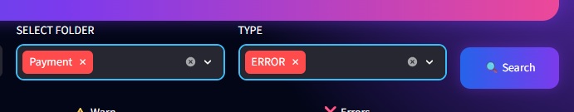

Records displayed successfully based on selecting a Folder and a Type.
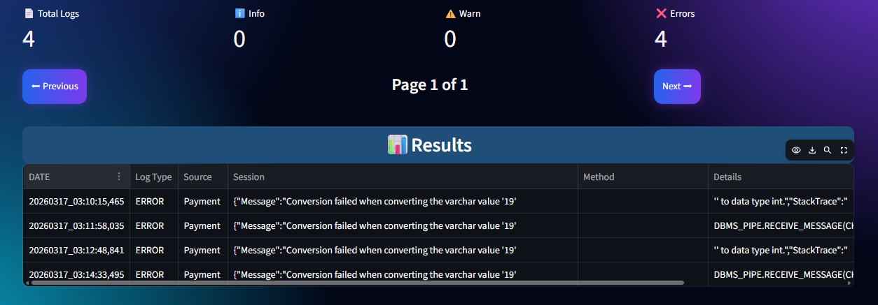

2. After multiselecting Folder and Type
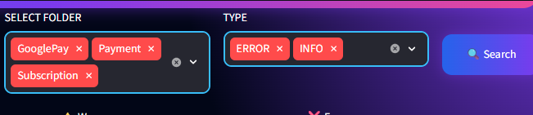

Records displayed successfully
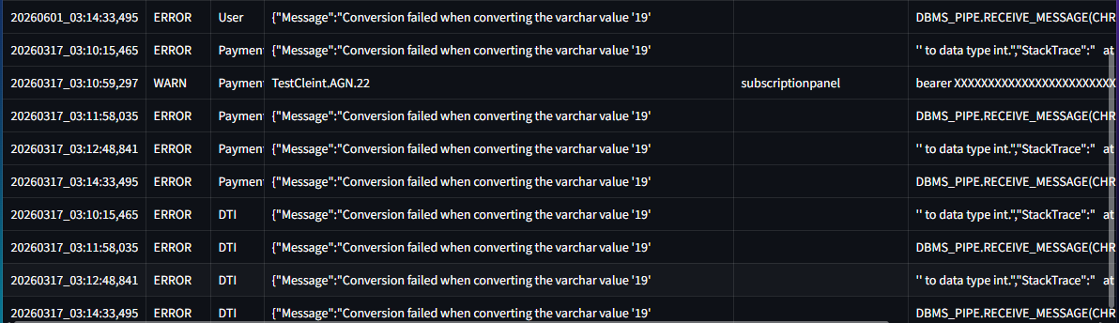

3. After selecting all Folders and multiselecting Type

Records displayed successfully
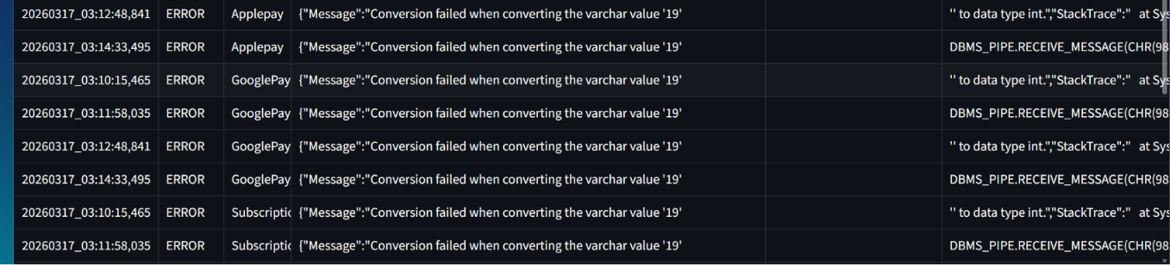

4. After selecting all Folders and all Types

records displayed successfully
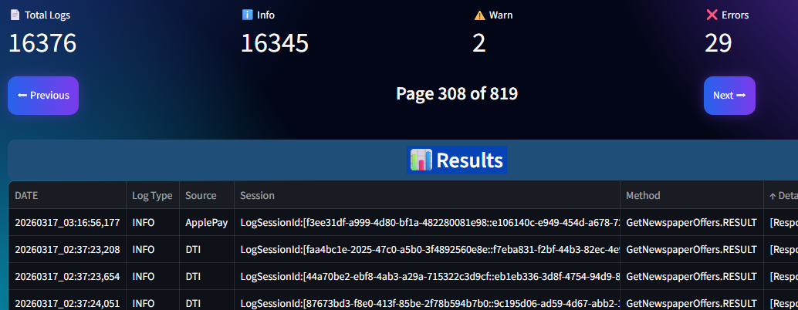

Test Case ID
TC_004

Test Case Name
Dashboard Displays Correct Search Result Count

Test Scenario
Verify Dashboard Displays the Correct Number of Search Results

Preconditions
N/A

Test Steps
1) Launch the application and Enter valid search criteria
2) Click the Search button.
3) Note the total number of search results displayed on the dashboard and verify the number of records displayed in the results table

Expected Result
- .The dashboard displays the exact number of records returned by the search criteria.

Actual Result

1. The dashboard displays -

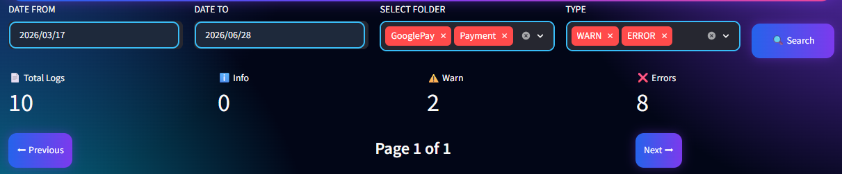

Records returned by search criteria

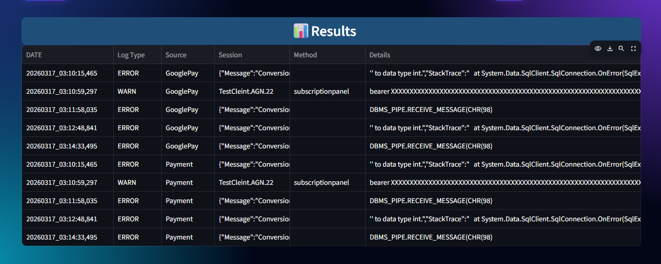

Test Case ID
TC_005

Test Case Name
Verify Toolbar Icons Representation and Functionality

Test Scenario
Verify that all toolbar icons (View, Download, Search, and Full Screen) are displayed correctly and perform their respective actions when clicked.

Preconditions
N/A

Test Steps
1. Open the application/page.
2. Verify that the View, Download, Search, and Full Screen icons are visible.
3. Click each icon one by one.
4. Observe the corresponding action for each icon.

Expected Result
All four icons are clearly visible, properly aligned, enabled, and clickable. Each icon performs its intended function correctly (View opens preview, Download starts download, Search opens search functionality, and Full Screen switches to full-screen mode). No UI distortion, overlap, or broken icons should be observed.

Actual Result
1. Verify View (👁) icon
The View icon is displayed correctly and opens the preview/view of the selected file successfully when clicked.

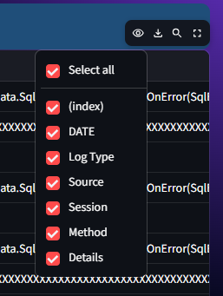

2. Verify Download (⬇) icon
The Download icon is displayed correctly and initiates the download of the selected file successfully when click

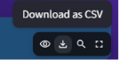

3. Verify Search (🔍) icon
The Search icon is displayed correctly and opens the search functionality or search bar successfully when clicked.
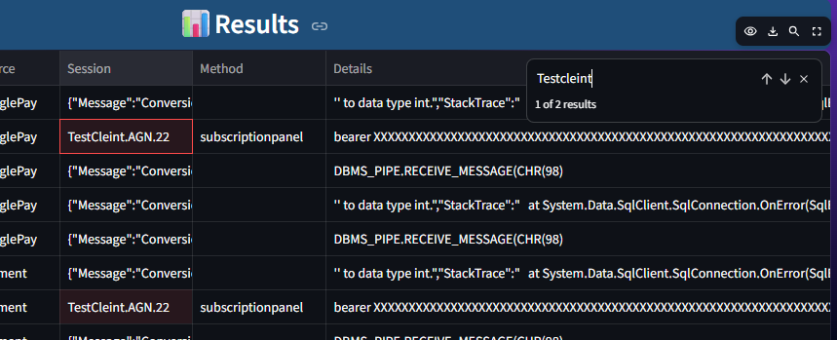
4. Verify Full Screen (⛶) icon
The Full Screen icon is displayed correctly and switches the document/view to full-screen mode successfully when clicked.

